AFTER ACTION REPORT

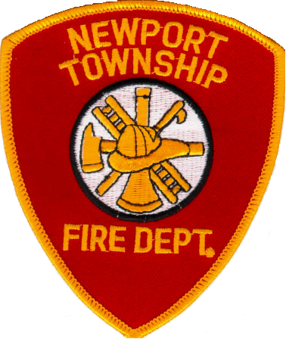

NEWPORT TOWNSHIP
FIRE PROTECTION DISTRICT

INCIDENT DATE:
10/27/07

INCIDENT TYPE:
MOTOR VEHICLE ACCIDENT

SPECIAL CIRCUMSTANCES:
INVOLVEMENT OF A TRAILER CARRYING HORSES

CONTENT

Executive Summary

Incident Narrative

Timeline

Special Operations / Equipment / Considerations

Recommended Actions for Future Incidents

Summary

About the Department

Report Information and Contact Information

EXECUTIVE SUMMARY
On Saturday, October 27th 2007 the Newport Township Fire Protection District (Newport) responded to a motor vehicle accident involving a pick-up truck and a semi-truck carrying 59 horses in a double deck cattle trailer which rolled over. The incident required the extrication of the horses. Newport was assisted by the Beach Park, Fox Lake, Gurnee, Pleasant Prairie, Round Lake, and Winthrop Harbor fire departments either at the scene or responding to other calls within the district. In addition to the fire service personnel on the scene; local veterinarians, members of the Lake County Mounted Posse, the Lake County Sheriff Department, and spontaneous volunteers assisted in the operation. The operation took 6 hours and challenged the technical capabilities of the department presenting many extrication obstacles on an aluminum trailer. The Command and Control aspect of the Incident Command system was also tested by insuring the safety of more then double the amount of non-fire service personnel working on the scene as fire service personnel. The initial accident resulted in the injury of two occupants of the pick-up truck who were transported to the hospital and the death of 13 horses on the scene. The remaining 46 horses were removed to a local farm for care and treatment pending disposition.

INCIDENT NARRATIVE

On Saturday, October 27th 2007 at 6:56 p.m. the Newport Township Fire Protection District (Newport) received a call for a vehicle accident with injuries at Route 41 and Wadsworth Road in Wadsworth, Illinois. Initial dispatch information indicated a semi-truck was involved and was rolled over. Reports also indicated that horses were in the trailer of this truck. This incident is located approximately ½ mile from the Newport Station.

Units responding on the initial dispatch were Ambulance 1442 with a crew of 4, Squad/Pumper 1458 with a crew of 4, Car 1401 with Assistant Chief Hubbard, and Car 1400 with Chief Kirschhoffer. Ambulance 1442 and Squad/Pumper 1458 arrived on the scene at 6:59 reporting a rolled over truck, and a car with heavy front end damage. Car 1490 with Lieutenant Schreiner was returning from a request for an ATV from neighboring Pleasant Prairie and immediately rolled into the station to put the second ambulance (1441) on the road. Lt. Schreiner had recently completed a 3 day class in Kentucky on the rescue of large animals.

Due to the number of people in the street and not knowing what vehicles may have been contacted by the semi that were not visible on the other side, Lieutenant Obos the officer of 1458 requested a Quad One North response. This predetermined response summoned Ambulance 1242 from the Beach Park Fire Protection District, Ambulance 1842 from the Zion Fire Department, and Ambulance 1741 from the Winthrop Harbor Fire Department. At this time 1441 was also arriving on the scene. Cars 1400 and 1401 arrived on the scene with Chief Kirschhoffer assuming command of the scene.

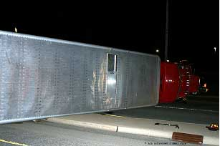
Initial assessment of the scene revealed that the pick-up truck was occupied by a male driver and female passenger, the female passenger was being assessed and packaged for transport while the male driver and driver of the semi were refusing aid and transport and were having paperwork completed for this. The semi was lying on the passenger side, there were no accessible doors, however; a roof vent was open. Some how, there had been no traffic southbound on Route 41 and no other vehicles had been impacted by the sliding truck. With no further human patients, Ambulance 1242 was diverted into Newport’s quarters and Ambulances 1842 and 1741 were cancelled. The driver of the semi informed rescuers that there were 59 horses in the trailer. Some of these horses were still kicking, others were whining occasionally, an awareness that there were already some fatalities from the incident and there would be further fatalities of these horses who were trapped and panicked was verbalized.
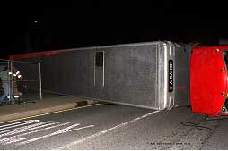
Lt. Schreiner informed command that veterinarians and fencing would be needed to be able to remove these horses safely. This request was made to the dispatch center just after 7:00 pm and calls for vets and fencing were begun from a resource list in the command car. A construction site was adjacent to the accident scene, and the temporary fencing around that site was disassembled, moved, and reassembled surrounding the rear and top (now the side facing north) of the truck. Tarps and blankets were placed on these fence areas to make them more visible to the horses, and obstruct outside view into the operation. While members of the fire department were accomplishing this task, an engine (1321) for additional manpower and extrication capabilities was requested from the Gurnee Fire Department. Lt. Schreiner was placed in charge of animal care and began keeping personnel away from the immediate area to protect them and to keep the animals from getting further upset and moving about. Along with this activity he began to document with photographs the condition of the vehicle. While continued documentation throughout the incident would have been the ultimate, manpower did not allow for this.
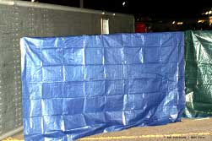
The suggestion was made by the LCSO that we allow the wreckers to hook up and upright the trailer with the horses in it. It is believed that this suggestion was driven by the thought that the horses would then be back on their feet and less endangered; however; the horses had had time to settle and move and tipping of the trailer again would have dislodged those that had gained their feet, and possibly thrown all of the occupants. The construction of the trailer also would not have allowed for this, and the possibility of the side blowing out and all the occupants being suddenly cast on the ground was a true possibility. Plans for extrication continued.

During this period the driver of the pick-up truck who had previously signed a refusal for transport decided to go to the hospital. Rather then pull additional resources off the scene Ambulance 1242 was requested from the Newport Station to transport him and a Winthrop Harbor Engine (1711) and Pleasant Prairie Ambulance (5242) were requested to fill Newport’s station.
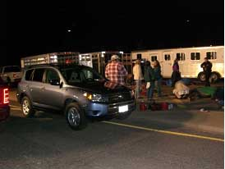
A call was placed to a local livestock handler for some expertise and use of a trailer if they were available. This person happened to be at a gathering of the Lake County Mounted Posse, this brought us a large number of people that were very familiar with horses, and a large amount of resources such as trailers, halters, lead ropes, and blankets that would be needed. It also provided the approval of one of the local residents with a large horse ranch to place the horses on their property in the interim.
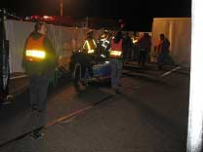
Initially members of the public that were there to assist with the horses were being identified by the use of command vests, but this number swelled and exceeded the number of vests available. The use of vests became dysfunctional later, and they were removed from these people.
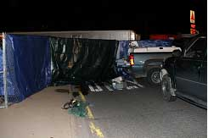
Fencing from the construction site was made into a corral and blankets from 1442 and tarps from 1458 were placed over them to both obscure the view of onlookers and make the barriers visible and solid looking for the horses. With the Gurnee engine on the scene to assist the Newport crews, Chief Kirschhoffer moved to the Operations position and Assistant Chief Hubbard assumed Command. Lt Schreiner continued with animal care coordinating with the vets and extrication teams and Lt. Obos was assigned as the Accountability Officer. As part of the accountability responsibility the names of all personnel that were in the warm zone (that area just outside the corral type area), were obtained. Additionally, only the fire department extrication crews and the minimal amount of volunteers needed for immediate animal care were allowed into the hot zone which was within the fenced in area. The fenced area was originally closed with only one opening 3’-4’ wide next to the trailer, which facilitated security of the area.

Heavy Rescue (1455) was requested to the scene, this unit provides large amounts of cribbing material, additional saws, torches, and supplies including low pressure airbags, tools, plywood, shoring and air shores and safety equipment that would normally not be available on an engine.

The first vets Dr Koehler and Dr Nelson arrived at 8:00 p.m.. The corral had been constructed, and extrication had begun. Lt. Schreiner had decided that the best course of action was to begin by opening the rear of the trailer. The plan in place was to expose parts of the trailer, allow the vets access to assess the animals and tranquilize those as needed, and remove them to the corral area. From the corral area the volunteers and members of the Lake County Mounted Posse (LCMP) along with the additional vets that were arriving would assess them, treat as needed and get them moved to the trailers that had been brought to the scene by members of the LCMP and local residents.
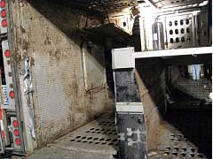
The trailer was aluminum construction, although lighter weight then steel, this in itself created a problem as torches were not of use because the aluminum melts and doesn’t cut, and the aluminum quickly dulls saw blades. By 8:07 Operations was requesting additional saw blades for the reciprocal saw, Command requested the change of quarters engine (1711) gather the additional saw blades from the Newport engine still in quarters and bring them to the scene. Heavy Squad 1455 was arriving and also had additional saws and blades.

Access to the lower section was obtained through the rear of the trailer and the vets were able to assess these horses. At this time the horses appeared to be worn out and in a state of shock from their form of confinement, the accident, and the sheer mass of horses that were in and on one another. Removal of the horses by the vets and firefighters began and the first horse was removed at 8:25.
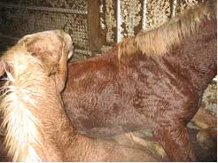
This lower section proved to be the most time consuming and dangerous. There was no direct access to the outside so rescue workers and vets would have to go into the vehicle to assess and remove the animals as well as continue the extrication. Whenever possible, it is best to open areas and let the animals come out of the confined area, which would allow rescuers to stay further from hoofs and heads and even the accidental leaning of a horse pressing their weight against the rescuer and trapping them against a wall. This would not be possible due to the inability to access the bottom layer from the side wall (in this case the bottom of the truck which is heavily reinforced), forcing all access to come from the rear of the truck and forcing the vets and rescuers to make access to these confined spaces. Due to the state of the horses on entry, many were not standing and were not able to stand or walk. These horses would be removed by hand.

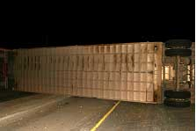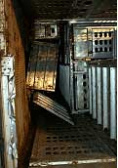
This lower section had dividers and doors which had to be opened and removed and hydraulic cutters and spreaders (holmatro tool –jaws of life type tool) were brought in from 1458. Throughout the incident various types of tools were used in different areas, and different levels of success were achieved. Circular (cut-off) saws, reciprocal saws, torches, hydraulic cutters & spreaders, air chisels, and hack saws were all used in areas. The tool that was most successful was the circular saw as the aluminum dulled the other blades quickly and was too soft for some of the other tools. Cutting teams worked in threes with one doing the cutter, a spotter and another who watched the backside for horses near and to wet down any sparking material.
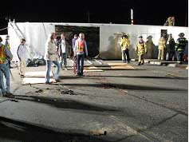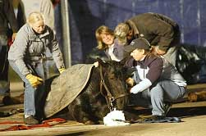
To accommodate the movement of the horses who could not immediately stand, ¾” plywood from 1455 had holes cut into it for hand holds and to accommodate webbing. These home made slides were used to move both live and dead horses without having to slide them on the ground. As horses were removed into the corral area they were cared for by the vets and assigned personnel from the LCMP and volunteers. Trailers had been positioned near the corral area and as the horses were calmed, warmed and able to stand and walk, they were brought to the trailers. This caused the corral area to be opened, and made it much more difficult to control personnel going in and out of the area.
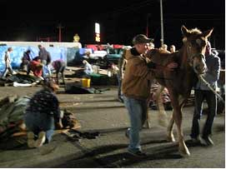
Due to not having an identification system in place, a great deal of time and effort was spent by Lt. Obos and 2-3 assistants to maintain a vigil on how many personnel were in the corral area, and what they were doing. A person was appointed to assist Lt. Obos and another was used to coordinate which trailer the horses were being put into. With no shipping papers available, a conversation occurred between command and operations about the possibility of the animals having some type of traveling sickness and/or being ill and the precautions that needed to be taken. Materials were to be treated as contaminated; those items that weren’t able to be decontaminated were to be discarded. Plans to alert the volunteers and provide tetanus and TB vaccinations for our personnel were also discussed.
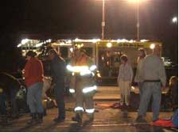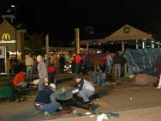
At 9:30 a status check was requested by Command. Operations advised that things were running smoothly, but units would be committed for at least another hour and a half. Command requested a Squad company (2251) from the Fox Lake Fire Department. This unit has two additional light towers and would supply fresh personnel for the operation. Additionally, the Metropolitan Emergency Support Services (MESS) was requested to provide warm fluids and refreshments for personnel on the scene. As operations progressed the corral area was opened up some near the trailers for removal of horses to the trailers. This opening was made even larger as horses had to be removed on the plywood slides. Horses that had perished in the crash were also removed to make access to viable horses, initially being placed in one of the trailers, and near that trailer as it filled.
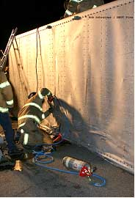
At 9:45 Operations requested another Chief to the scene as an additional cutting operation was needed to speed things up. Command requested Car 2600, Chief Maplethorpe of the Round Lake Fire Protection District. Chief Maplethorpe came on the air enroute to the scene and advised that Command 2 (communications and command vehicle) was available and he had it headed our way as well. A request was made from Command for an additional Squad company (2651) from the Round Lake Fire Protection District at 10:11 to supplement the personnel on scene.

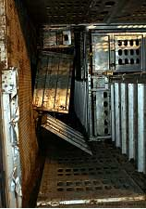
With the arrival of 2600, 2251, and the Mess Canteen additional lights were placed, a second cutting operation was put into place; personnel were able to get some liquids, and an additional safety officer (Lt. Miller – Fox Lake) was put into place. The bottom portion of the trailer had been emptied and operations were progressing on the upper level. Prior to removal of the roof sections, portions of the corral area had to be moved and reconfigured as the initial lay out only took in the rear of the trailer and about half of the roof area, and removal of the roof area would require that it be fenced in, in its entirety. Fencing from the rear was moved forward, and fencing that was in the middle of the roof was moved to the cab area, these operations left a large opening away from the truck near the trailers and made control of the access extremely
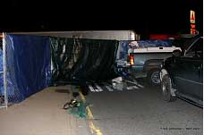
difficult. Gaining access to the upper section would entail removing the entire roof section due to the compartmentalization of the trailer. These sections were removed one at a time to help manage the number of horses that were released. Because of the ability to remove these sections and have outside access, horses were accessed faster, and more were on the ground and being treated simultaneously creating a more congested area within the corral area.

Early in the incident the need for a rendering service was identified. The task of locating this service was taken on by an assistant of Dr. Koehler. The rendering services wanted assurance that they were getting paid and by who, this was resolved at this time with the appearance of an adjustor for the insurance company. With permission to obtain those services, a briefing was done on our status. The presence of a representative that was able to take responsibilities was a big help and assisted in those clean-up times.

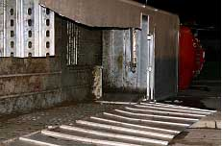
Command was updated at 10:32 that 36 horses had been removed from the trailer and 23 remained to be removed. It had taken nearly 2 ½ hours to remove the first 36 horses due to the configuration of the lower section and having to remove them individually. As the initially crews continued to open roof sections from the rear of the trailer forward, the second cutting operation was beginning in the front. Along with opening the roof they were met some unique problems such as a horse having a leg through a side opening and being pinned. This problem was resolved by making some relief cuts around the area and then utilizing air bags to slightly lift the trailer while assisting the horse in removing the leg from the hole. This operation took place while additional cutting operations continued. At the very front of the trailer one of the compartments would require the horses to walk down the angle of the trailer, to assist the footing, some of the plywood slides were brought in and placed for the footing. Where cuts had been made there were some sharp edges, to avoid any further injury extrication crews were using duct tape on the edges of cuts. Later in the incident as cuts got lower, volunteers
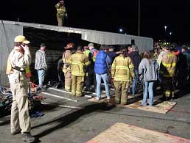
would line the exit way of the horse so they would not stop off or walk into a sharp edge.
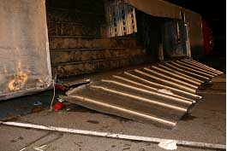
At 11:03 the last horse was removed from the trailer. The final 23 horses were removed in just over 30 minutes, this was just over 4 hours into the incident and 3 hours since extrication had begun. At this point Command requested an accounting of the horses. Of the 59 horses, 46 were loaded into trailers and transported, 9 had been killed in the accident or died prior to rescuers getting to them, and 4 were not in a savable condition and had to be put down by the vets at the scene. The final live horses were treated by the vets and loaded into the trailers and the trailers went as a convoy to their destination.

All attempts were made at this point to ask the photographers on the scene not to photograph the deceased horses being loaded onto the flat bed for transport. Those horses and the deceased ones that were earlier loaded into one of the trailers were transported to the Newport Fire Station. While this loading was occurring all volunteers, vets, and fire personnel were gathered to remind them that there was a possibility that the animals had been contaminated, that all clothing and materials should be cleaned, and equipment should be decontaminated or discarded. Shortly after the deceased horses arrived at the station, the rendering company arrived and took possession of them.

With the removal of the last live and deceased horses, the up righting of the truck and trailer occurred and the area where it had been was washed down with water and bleach. Units continued to gather equipment and upon returning to the station equipment was cleaned and replaced although many items were broken or all items of that type had been used.
Clean up and replacement went well into the next day with replacement supplies and equipment being ordered on Monday. A critique of the incident was conducted by fire department personnel on Tuesday evening, and plans were made for a critique with the vets and volunteers.
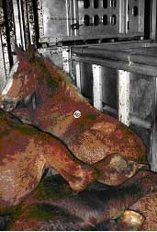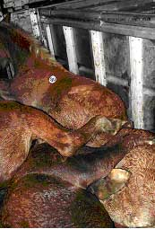
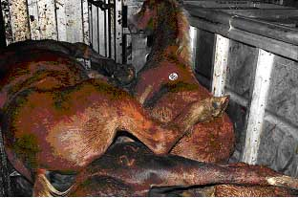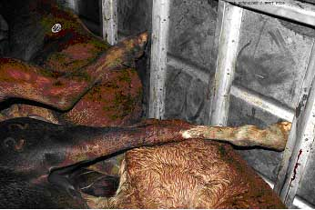
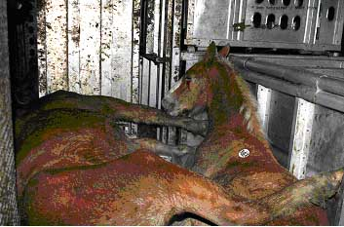
TIMELINE

6:54 p.m. Gurnee Dispatch receives call
6:56 p.m. Newport Fire Toned for Incident
6:57 p.m. Car 1400 (Chief Kirschhoffer), Car 1401 (Assistant Chief Hubbard), Squad/Pumper 1458, Ambulance 1442 enroute
6:59 p.m. 1458 and 1442 on scene Quad One North requested
7:00 p.m. Ambulance 1441 enroute
7:01 p.m. 1400 on scene and Command, 1401, 1441 on scene
7:06 p.m. Ambulance 1242 (Beach Park) enroute
7:08 p.m. Ambulance 1741 (Winthrop Harbor), Ambulance 1842 (Zion) enroute
7:09 p.m. Cancel the Quad One response – 1242 to Newport Quarters
7:15 p.m. 1442 transporting 1 to Condell
7:24 p.m. Gurnee requested with an engine (1321)
7:28 p.m. Fencing from construction area being moved for corral
7:29 p.m. 1321 on scene
7:33 p.m. 1242 requested to scene for 2nd patient
7:38 p.m. Dr Koehler and Nelson enroute (15 minute ETA)
7:39 p.m. Dr Hanover enroute (45 minute ETA)
7:41 p.m. Winthrop Harbor Engine (1711) and Pleasant Prairie Ambulance (5242) requested change of quarters to Newport Station
7:55 p.m. 1442 returning to scene
7:58 p.m. 1242 transporting 1 to Condell
7:59 p.m. 1711 and 5242 in Newport Station
8:00 p.m. Dr Koehler and Nelson on location
8:07 p.m. 1711 requested to scene with additional saw blades
9:13 p.m. 1242 available at Condell, returned to their Quarters
9:45 p.m. Fox Lake Squad (2251) requested
9:45 p.m. Mess Canteen requested
9:45 p.m. Car 2600 – Round Lake Chief Maplethorpe requested
10:04 p.m. 2251 location
10:11 p.m. Round Lake Squad (2651) requested
TIMELINE CONTINUED
10:14 p.m. 2600 location
10:16 p.m. Command 2 location
10:30 p.m. 2651 location
10:32 p.m. 36 horses removed, 23 remaining
11:03 p.m. Last horse removed
12:36 a.m. Change of Quarters Companies (1711 & 5242) released
12:50 a.m. Mutual Aid Companies (1321, 2251, 2600, 2651) released
1:00 a.m. Command Terminated
1:06 a.m. Newport Units (1400, 1401, 1441, 1442, 1458, 1475, 1490) in quarters

Special Operations / Equipment / Considerations

While this incident involved many daily operations including Extrication and Incident Command, even those functions required adaptation. Some portions of the operation were not ones that the fire service undertakes routinely (removal, care, and treatment of the horses) and these operations called for the use of expertise, materials that are not normally available, and the coordination of personnel unfamiliar with the Incident Command System. In this section the intent is to highlight some of the items that went right, and some equipment and considerations that are needed for an incident of this nature.

EXPERTISE/ TECHNICAL RESOURCES
The need for technical support and expertise cannot be overstated. In this instance fire personnel had attended a one day class on handling large animals, one member had attended a three day class on handling and moving horses, and several members were familiar with and/or owned horses. This knowledge helped initially in allowing the department to identify and obtain the equipment needed as well as maintaining the area and protecting personnel and the horses. Another important source was the immediate request for and response of veterinarians. The department had obtained names and numbers of several area vets and kept those available in both the command units and the dispatch center. The vets also notified each other and a quick response from a large number (5) of them allowed for the ability to have them work with extrication members as the animals were reached, and have members treating them outside. Having these vets on scene not only allowed a luxury of comfort in decisions that were being made similar to having an emergency room doctor on location for humans, but also caused a large buy in immediately by the volunteers and LCMP who knew the value and care that the vets provided. Without this buy-in many of the operations and decisions could have been delayed while personnel on the scene questioned them. Having people on the scene (Lake County Mounted Posse and volunteers) that were familiar with handling horses assisted in the safe handling but also allowed more fire personnel to be available for extrication duties.

SPECIALIZED EQUIPMENT
Certain items that are distinct to animal rescue type of incident are needed.
Fencing (or some sort of corral material) - In this event we were fortunate to have a construction area on the side of the incident that had metal fencing with supports available. The need for this type of material had been identified by Lt. Schreiner upon his return from a class on horse handling and the ability to use snow fencing and some poles had been discussed but not yet put in place. The construction fencing utilized was also draped with tarps and blankets to allow for better visibility of the barrier to the horses and to obscure visibility from the outside of the incident.

Trailers – Needed for containing and moving animals. These were obtained by notification of a local farmer who happened to be at a party with members of the Lake County Mounted Posse, but a phone tree among a local group of animal owners would work
Halters/Harnesses/Leads – Needed for gaining a hold and leading animals. These were also brought to the scene by the LCMP and volunteers, but the animals can be led/held by fashioning these out of webbing/rope as well.
Blankets – Used to allow the animals to rest on the concrete, dry them, and help retain warmth. These were brought by the LCMP and volunteers. More then was available on the ambulances would have been needed.

Slides – They make commercial poly plastic slides, none of these were available to us that night, slides were constructed using ¾” plywood cutting holes in them for handholds and for attaching webbing..

Identification – An attempt was made to identify those who were working at this incident by using command vests. However; the amount of members of the LCMP and spontaneous volunteers quickly outnumbered the vests that were available. Identification of those that should have access to the scene is critical for safety. A form of identification that is easily identifiable yet difficult to duplicate should be available. Some form of armband may serve this purpose.

Facility – In this incident we were offered a facility to move the horses too. With the realization that most animals in transit could have some form of communicable disease, especially those without proper shipping papers, transport to an active farm could be very dangerous. In this instance, the animals did have some diseases that are being treated by the vets, it has also caused a great deal of dysfunction and oversight for the farm where the animals were taken. The name and location of the relocated animals was not released by the fire department and every effort was made to stress the importance of others not knowing this location, but it did get out. Besides the large number of curious people, this farm has had to endure the media, governmental agencies and their reviews, and animal rights activists that have threatened actions against someone who is trying to help the animals. Knowing where some facilities are that will not have this interaction with active animals or cause this type of disruption would be very helpful.

NATIONAL INCIDENT MANAGEMENT SYSTEM / INCIDENT COMMAND
While the Incident Command System (ICS) was easily adapted to this incident the majority of the personnel on the scene (LCMP and volunteers) had not been exposed to the system. Having additional fire personnel there and marrying them up with a group of 4-6 volunteers for assignments would have added to the incident coordination and safety. Providing classes to these groups or providing means for them to practice them or achieve this training would assist in many different types of incidents, not just this one. Training in this system can be beneficial to them as they interact with you on this type of incident, or in creating some type of response organization amongst themselves.

Recommended actions for future incidents

Listed are items that are necessary for a successful outcome to a similar incident. Most of these were available or occurred at this incident, some are a learning process from the incident, and yet others came out from a post incident critique.

Resource List – Having a resource list available is essential. This list must contain twenty-four hour access numbers for veterinarians, people that access to trailers, fencing if not available through the department, rendering services and various animal care needs (harness, halter, blankets). This list must be updated frequently so that when it is needed time isn’t lost calling the wrong numbers, it must also be available at the dispatch center and on the scene.

Pre-Incident Meetings – Meeting with the various vets and animal groups prior to an incident can help answer many questions about what meds and supplies are available, what equipment could be needed to handle this type of incident and if it is available. What kind of working relationship the vets have, how many members various clubs have and what kind of phone tree alerting system they have. Learning of their knowledge of NIMS is also important.

Equipment – While much of the equipment (fencing (gates), trailer, halter, harness, webbing, tarps, blankets, slides, slings) would only be needed by a department once in a lifetime, this type of equipment is vital in the early stages of an incident. By having a group(s) put this together it will save valuable time during an incident of this magnitude or smaller, many of the items can come in handy even in a single animal event, and build good will for the department for its awareness and response to such incidents. By assisting in creating the list, and coordinating its response and use the department can be much more prepared with little cost to the department. Searching for equipment at the time of the incident can eat up valuable resources that could be invested in the scene. Some of the equipment is fire department equipment and can/could be used on a wide variety of incidents. With the wide use of aluminum and aluminum overlays a department must have a variety of saws and tools available to them to adapt to the situation, remembering that the aluminum tends to dull the blades quickly and a larger number of blades will be needed. This can be accomplished through having additional blades available or calling in additional resources which will have additional blades and/or tools. A means of identifying non-emergency service personnel that you want to have access to the scene is needed. This will help law enforcement keep bystanders and photographers out of your scene without slowing your operation by having needed workers kept out. Having some form of arm-band available that could be distributed as people sign-in and are organized into working teams seems to be the best idea. This form of identification is visible even if weather conditions call for outer garments. Some type of color coded arm-band could be used and by alternating the colors you can keep the arm-band from being kept and used again on another scene without checking in. This would also require persons from outside the emergency services to check in at one point to obtain these to gain access and would provide an opportunity to marry a group (4-6) of volunteers up with a fire service person so that they could be assigned specific tasks, have their own safety type officer, have communications through the fire service personnel, and insure that if they didn’t have a task they were removed from the active area and safe.

Training – Having some basic training on animals and their reactions is a must. Working with local groups it is usually fairly easy to set-up classes to allow the firefighters to learn how to wrap rope to for a temporary lead device, and how to move the animals. Some more in depth training may be available locally as clubs/organizations attempt to educate the first responders, and distant training such as the class in Kentucky may be an option through the local clubs/organizations (as it was for us with the Lake County Mounted Posse paying for the registration and accommodations) and bringing that knowledge back to others in the department. On the flip side, meeting and providing training for the club/organization on NIMS can help them gather a better understanding of your mission, as well as fit into your (or some other departments) Incident Command Structure. This will not only assist them in meeting national initiatives, but will provide a sense of security for the Incident Commander and help insure their safety at an incident.

Personnel – Requesting additional emergency service personnel early in the incident is beneficial. Even personnel that are not familiar with large animals can be a great asset, allowing personnel to be available to rotate into extrication positions, keeping personnel fresh and safe and by filling other positions, some of these positions are:
Team Coordinator – assigning a fire service person to each small group of volunteers to provide them with a safety officer as they work around fire department operations, providing radio communications so that they are available for various assignments and assistance can be accessed rapidly if needed, and to coordinate their movements in the area.
Area Security – with law enforcement committed to traffic and area security, having additional personnel that can keep personnel from wandering into hot and warm areas or can help identify these areas is an asset.
Staff Functions – providing personnel that can act as in the role of staff functions will help provide a safer, and more efficient operation during and after when you are trying to get back in service for the next call.
Public Information Officer – Gathering information and disseminating it to the various news organizations can help the department to not only get the correct information out, but to help them be identified in being intimately involved in the incident and as part of the good work being done. It also gives the department an opportunity to thank those who stepped up and offered their time, services, and equipment. Without this in place other organizations may take the lead and fail to get the facts straight, or take credit for your departments efforts.
Safety Officer – Utilize twice the amount you would normally establish due to the number of non-emergency service personnel. Try to pair a Safety Officer that can identify the fire service operation hazards with someone that can identify the hazards to and from the horses/animals so they can work in tandem to provide safety to the workers and the animals.
Logistics – Utilize to find additional items as needed, and record items used so you can have a good record of what needs replacement and so that you can recover costs if that is available.
Recorders - Document both written and photographically what you have established, what procedures were used, and important benchmarks. This will assist both in report writing and if you ever have to defend your actions in court.
Utilize initial non-emergency service personnel to help coordinate other non-emergency service personnel. Getting someone to be a point of contact in one location so everyone can sign in and be identified, and utilizing personnel that you have met with and have an understanding of their knowledge for coordinators and safety aspects will assist in lessening the Incident Command strain that can occur with such large numbers of non-emergency service personnel.
STEPS FOR FUTURE INCIDENTS
- Request Law Enforcement shut down adjacent roadways and secure the area. Even a small event will require considerable space for staged responding units and possible loose livestock capture and storage.

- Consider additional resources, consider MABAS Box.

- Notify Dispatch to call Veterinarians from pre-established resource list
on file at dispatch and in pre-plans.
  - Minimum 2 veterinarians and more for larger events.
  - One veterinarian should be utilized with a Chief Officer or trained Safety Officer as a Safety Sector.

- Notify appropriate agency from pre-established resource list for fencing or panel gates to be brought to the scene. A search in the immediate area may find temporary construction fence, which can be used. There is high probability webbing will be needed to tie the gates or panels together.

- Transportation of livestock requests will be handled through the pre-established livestock haulers list, which needs to be on a resource list.

- Sectoring considerations:

  - Command with an aid and consideration of Command Unit.
  - Safety with a Veterinarian assisting
  - Staging both forward and secondary for livestock haulers and additional units not necessary for the operation.
  - Operations
  - EMS with an available ambulance for rescuers.
  - PIO, large animal rescues attract great media attention.

Staffed ambulance at all times for large animal rescues due to high probability for injury.

SUMMARY

On Saturday, October 27th 2007 the Newport Township Fire Protection District (Newport) responded to a Motor Vehicle Accident involving a pick-up truck with two patients and a semi-truck carrying 59 horses in a double deck cattle trailer which rolled over. The incident required the extrication of the horses. Newport was assisted by the Beach Park, Fox Lake, Gurnee, Pleasant Prairie, Round Lake, and Winthrop Harbor fire departments either at the scene or responding to other calls within the district. In addition to the fire service personnel on the scene; local veterinarians, members of the Lake County Mounted Posse, the Lake County Sheriff Department, and spontaneous volunteers assisted in the operation. The operation took 6 hours and challenged the technical capabilities of the department presenting many extrication obstacles on an aluminum trailer. The need for multiple tools for the various portions of the trailer was identified as was the need for extra blades and tools due to the dulling properties of the aluminum. The need for non-emergency service personnel that understand and work with the animals is needed, but this will require additional fire service personnel to assist in coordination and for safety considerations. The Command and Control aspect of the Incident Command system was also tested by insuring the safety of more then double the amount of non-fire service personnel working on the scene as fire service personnel. The initial accident resulted in the injury of two occupants of the pick-up truck who were transported to the hospital and the death of 9 horses, an additional 4 horses had to be put down at the scene by the veterinarians on the scene. These 13 expired horses on the scene had to be removed and the services of a rendering company was needed. Having a representative of the insurance company on the scene assisted in gaining the services needed (rendering service) and gave us the opportunity to explain why some of the operations we were performing which they were going to be billed for were necessary. The remaining 46 horses were removed to a local farm for care and treatment pending disposition. The incident gained large amounts of media and public attention. The need to have a Public Information Officer identified was evident in the requests that were made and the contacts to the fire department after the incident, as contact from throughout the United States has been made. Unwanted attention and scrutiny has been received by the local landowner that allowed the horses to be boarded on his property. This has come in the form of media, visitors, animal activist groups, and public officials/agencies. The horses did have contagious diseases as suspected, and their care continues. The incident required 6 hours of on-scene time, several days of cleaning, disinfecting, repairing, and replacing equipment and supplies, and more time answering public questions and concerns (mostly very positive) regarding the incident. A department critique of the incident was held and a public critique for non-emergency service personnel who were involved in the incident is underway. This critique will include representatives of the mental health department to provide information on resources and behavior that these people may need/experience having never seen such sights before. The incident tested the resources of the department and the other fire service agencies that assisted, but resulted in a smooth, successful, operation that allowed for the survival of the majority of the affected animals.

ABOUT THE DEPARTMENT

GEOGRAPHIC AND DEMOGRAPHIC INFORMATION
The Newport Township Fire Protection District (NFD) is in Lake County Illinois which is located in the northeast portion of Illinois placing it strategically between Chicago and Milwaukee being 40 miles from each. The NFD provides protection to a 33 square mile area which is primarily residential, but does have three major interstate / state highways and two railroads passing through it.

The NFD protects a population of over 7,000 residents (the 2000 census of 4,120 with a housing development started in 2004 and still building with more than 850 homes and greater than 3,000 residents) and responds to an average of 900 emergency calls annually. The NFD has positive water in less than 5% of its response area and relies heavily on a series of dry hydrants, ponds, and neighboring jurisdiction’s water sources.

FACILITIES
The NFD operates out of a single station which was built in 1945 with three additions, the last of which was in the early 1990’s. This station has eight bays; one apparatus deep. The NFD facility is the only public facility available to all township residents and is often used by citizens and other public bodies for classes and public meetings.

PERSONNEL
The NFD employs 6 full-time line firefighter/paramedics and 40 paid on call personnel. These paid on call personnel come from all walks of life, and very few work locally or are available during the day for responses. Personnel are all trained to state standards with the majority continuing with advanced or specialized classes and weekly training. Training is unpaid time, volunteered by the members.

APPARATUS
The NFD operates the following apparatus:

Engine 1977 Mack
Squad 1983 Box Truck
SRT Squad 1987 Crane Truck
Engine/Tender 1989 Pierce
Command Car 1997 GMC Tahoe
Engine 1995 Pierce
Engine 1999 Pierce
Tender 1999 Peterbuilt
Ambulance 1999 Medtec
Brush Truck 2000 Ford
Ambulance 2006 Medtec
ATV 2007 Kubota

AUTOMATIC AND MUTUAL AID
The NFD provides automatic aid to 7 surrounding fire departments as well as being a MABAS member (Mutual Aid Box Alarm System – this is a mutual aid agreement that has encompassed all of Illinois, and has begun to be adopted by departments in Wisconsin, Indiana, Ohio, and Missouri) and participates in mutual response and purchases with the departments of Lake and McHenry Counties in Illinois, Kenosha County in Wisconsin. The NFD has been involved in state wide responses, which has included 2 personnel for 4 weeks in New Orleans and a task force response to central Illinois. The NFD responds frequently on automatic and mutual aid, approximately 40% of its call volume being to surrounding communities for assistance.

ABOUT THE REPORT / FURTHER INFORMATION

This report was written as an effort to provide information to other agencies that may experience this type of incident. Further information regarding this incident can be obtained from:

Chief Mark Kirschhoffer
Phone (847) 336-1080
Fax (847) 336-1097
Email chief@newportfire.org
Assistant Chief Joe Hubbard
Phone (847) 336-1080
Fax (847) 336-1097
Email j.hubbard@newportfire.org

